**Appendices**

**Contents**

Appendix A: IPIP Big-Five Factor Markers Questionnaire by Goldberg (1992) …… 2

Appendix B: Learning outcome multiple choice quiz (MCQ) ………………………… 5

Appendix C: Experimental stimuli ……………………………………………………… 11

Appendix D: Participant information and consent form ……………………………… 19

Appendix E: Data analysis ……………………………………………………………… 21

**Appendix A**

IPIP Big-Five Factor Markers Questionnaire by Goldberg (URL: <https://www.cmu.edu/common-cold-project/measures-by-study/psychological-and-social-constructs/personality-measures/big-five-personality-factors.html> )

|  |  |  |
| --- | --- | --- |
| Five dimensions of personality | Positively phrased items | Negatively phrased items |
| Extraversion | 1. I am the life of the party.   11. I feel comfortable around people.  21. I start conversations.  31. I talk to a lot of different people at parties.  41. I don't mind being the centre of attention. | 6. I don't talk a lot.  16. I keep in the background.  26. I have little to say.  36. I don't like to draw attention to myself.  46. I am quiet around strangers. |
| Agreeableness | 7. I am interested in people.  17. I sympathize with others' feelings.  27. I have a soft heart.  37. I take time out for others.  42. I feel others' emotions.  47. I make people feel at ease. | 32. I am not really interested in others.  12. I Insult people.  22. I am not interested in other people's problems.  2. I feel little concern for others. |
| Conscientiousness | 1. I am always prepared.   13. I pay attention to details.  23. I get chores done right away.  33. I like order.  43. I follow a schedule.  48. I am exacting in my work. | 8. I leave my belongings around.  18. I make a mess of things.  28. I often forget to put things back in their proper place.  38. I shirk my duties. |
| Neuroticism | 1. I get stressed out easily.   14. I worry about things.  24. I am easily disturbed.  29. I get upset easily.  34. I change my mood a lot.  39. I have frequent mood swings.  44. I get irritated easily.  49. I often feel blue. | 9. I am relaxed most of the time.  19. I seldom feel blue. |
| Openness | 1. I have a rich vocabulary.   15. I have a vivid imagination.  25. I have excellent ideas.  35. I am quick to understand things.  40. I use difficult words.  45. I spend time reflecting on things.  50. I am full of ideas. | 10. I have difficulty understanding abstract ideas.  20. I am not interested in abstract ideas.  30. I do not have a good imagination. |

**Appendix B**

Learning outcome MCQ.

**Well done! You have reached the end of the tutorial.   
Now, we will get you to do some tasks to see if our tutorial has been effective in teaching you how to clean datasets using R. Normally, statisticians deal with large amounts of data. However, to keep this simple and easier for beginners, you'll be dealing with smaller datasets.  
  
  There will be 10 multiple-choice questions with one question being displayed per page. We would like for you to attempt all the questions. There is no time limit for this.**

B1. Which of the following functions can you use to keep **columns**?

1. %>%
2. **select()**
3. filter()
4. group_by()

B2. Which of the following functions can you use to keep the **rows** you’re interested in?

1. group_by()
2. select()
3. **filter()**
4. %>%

B3. Here is a table containing our data to the scores on an exam that different people working in different industries took, as well as their gender.

|  |  |  |  |
| --- | --- | --- | --- |
| name | industry_job | score | gender |
| G | healthcare | 64 | M |
| A | food | 81 | F |
| J | research | 90 | F |
| A | research | 20 | M |
| L | retail | 43 | M |
| J | healthcare | 66 | F |
| M | retail | 54 | M |
| D | food | 24 | M |

For this dataset, we’re interested in cleaning this data to show that it only shows rows containing “healthcare” under their industry job column. Which of the following code is correct for this?

1. data %>% select(industry_job == “healthcare”)
2. data %% filter(industry_job)
3. data %>% select(industry_job & “healthcare”)
4. **data %>% filter(industry_job == “healthcare”)**

B4.  Here is an example of a table with participants’ ID, their age, favourite colours, gender and the participant’s scores on a mini quiz they did in class.

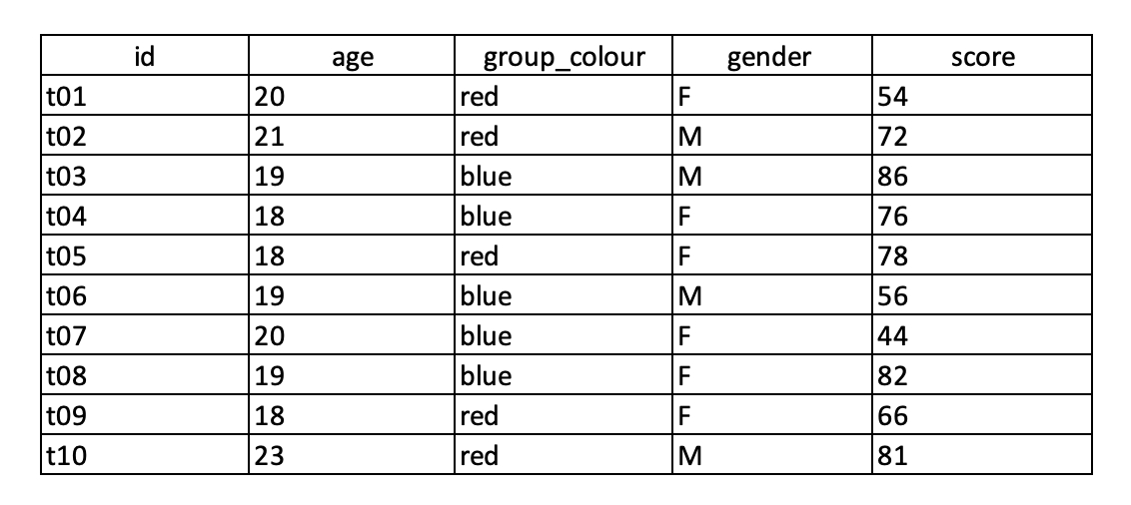

We are interested in only keeping rows that contain “red” from the group_colour column. Please choose the code line that is correct for this.

1. **data %>% filter(group_colour == “red”)**
2. data %% filter(id, group_colour, score)
3. data %>% select (id, group_colour)
4. data %<% select(group_colour == “red”)

B5. Here is the same table from the previous question.

We want to clean this dataset so that it only shows rows containing “blue” from the group_colour column, and “F” (female) from the gender column.

Please choose which code line is correct to execute this.

1. **data %>% filter(group_colour == “blue” & gender == “F”)**
2. data %<>% filter(blue == group_colour ) %>% select (gender == “F”)
3. data %<% filter (group_colour & gender) filter %>% (“blue”)
4. select(group_colour == “blue” & gender == “F”)

B6. Here is the same table from the previous question.

We want to clean this dataset so that it shows the gender of those that have “red” as their group colour. How would we code this?

1. %>% select (gender) %>% filter(group_colour == “red”)
2. **data %>% filter(group_colour == “red”) %>% select(gender)**
3. data %>% filter(gender == red)
4. data %<% select(group_colour, gender) %>% filter(group_colour == “blue”)

B7. Here is the same table from the previous question

We are interested in cleaning this dataset in a way that shows only the score column of females. Fill in the blank in our code below to execute this.

data %>% _____ (gender == “F”) %>% select (score)

1. mutate()
2. select()
3. %>%
4. **filter()**

B8. Here is the same table from the previous question

This time, we are interested in cleaning this dataset in a way that shows only the score column of males. Fill in the blank in our code below to execute this.

data %>% filter ( _________ ) %>% select ( score )

1. gender & “M”
2. **gender == “M”**
3. gender, “M”
4. score == “M”

B9. Here is the same table from the previous question

Here, we are interested in cleaning this dataset in a way that only shows rows containing “red” under the group colour column, and females under the gender column. We attempted to use the following code below, however this is wrong. Identify the error in this code:

data %>% select ( group_colour == “red” & gender == “F” )

1. data
2. (group_colour == “red” & gender == “F”)
3. %>%
4. **select()**

B10. Here is the same table from the previous question   


We want to clean this dataset so that it shows the score of those that have “M” as their gender. How would we code this?

1. **data %>% filter(gender == “M”) %>% select(score)**
2. data %>% filter (gender & score ) %>% select (M )
3. data %>>% select ( score) %>>% filter ( score == “M” )
4. data %>% filter (score)

**Appendix C**

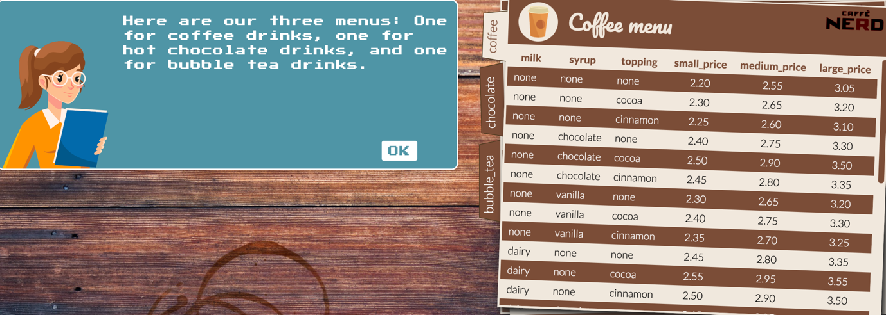C1**.** A female manager introducing the Coffee menu to participants in the gamified tutorial.

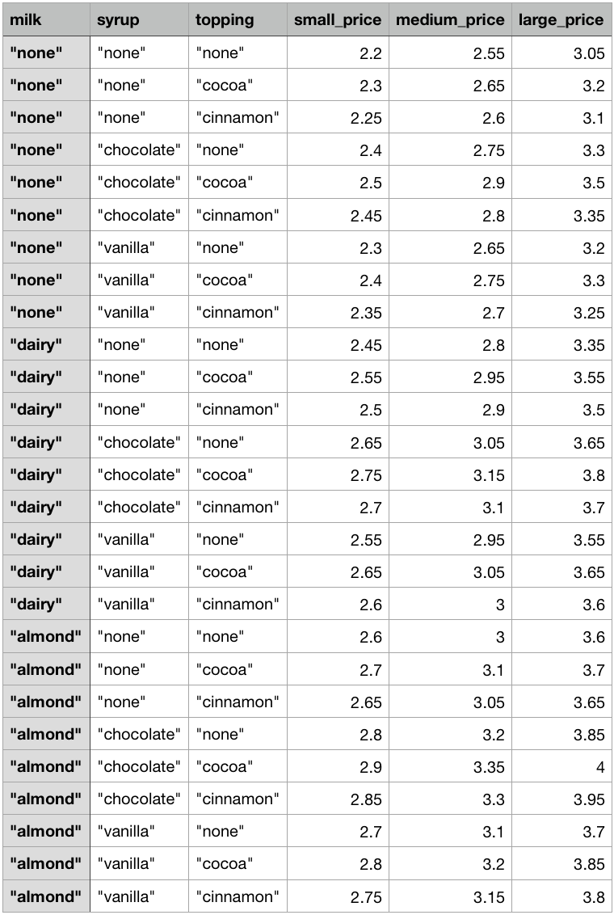C2. Coffee dataset displayed to participants in the non-gamified tutorial.

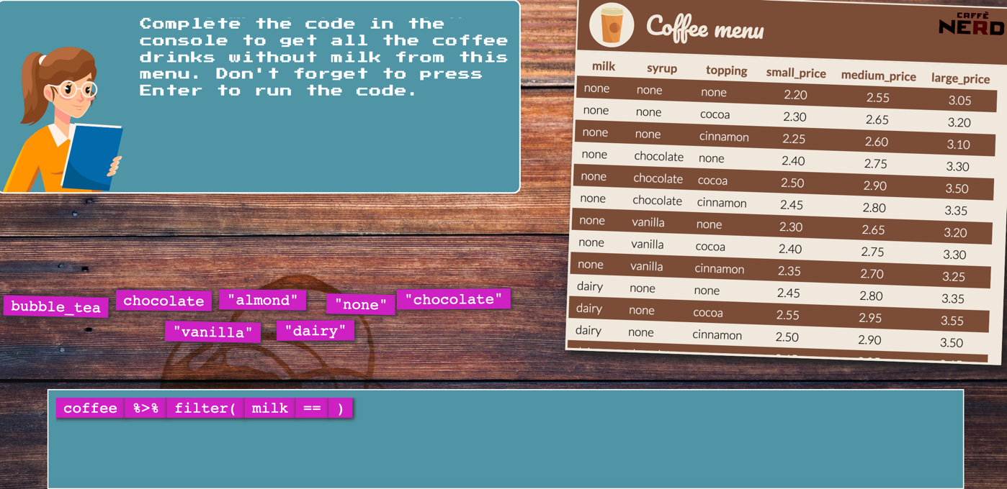C3. An example of a drag and drop exercise in the gamified tutorial.

C4. An example of a MCQ exercise in the non-gamified tutorial.

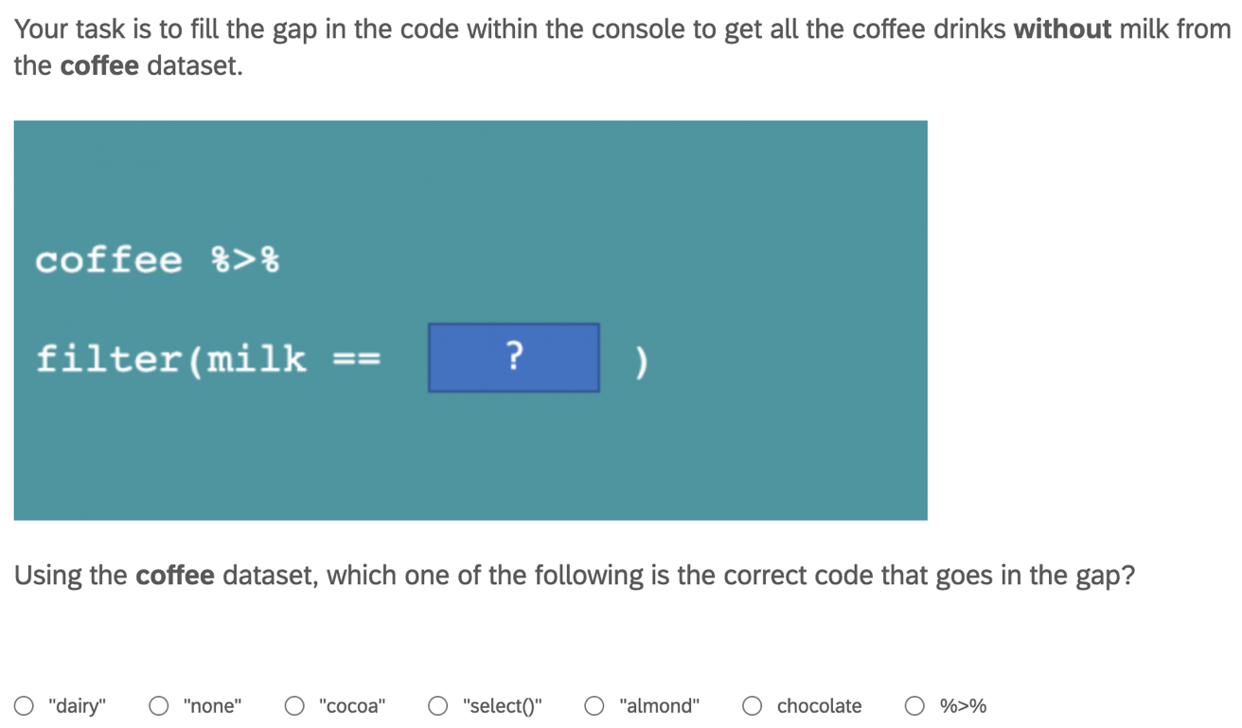

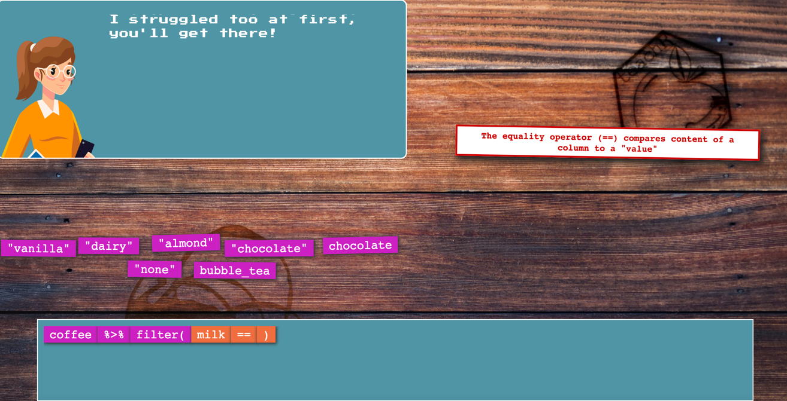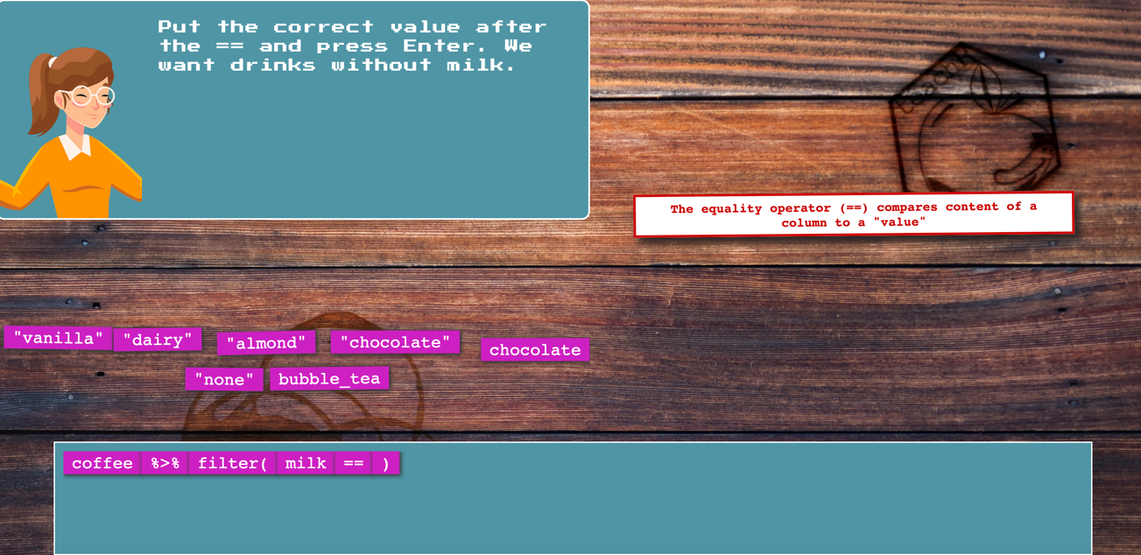C5. Examples of verbal feedback given to participants when the wrong code was chosen or misplaced in the gamified tutorial.

C6. An example of verbal feedback given to participants when the wrong code was chosen in the non-gamified tutorial.

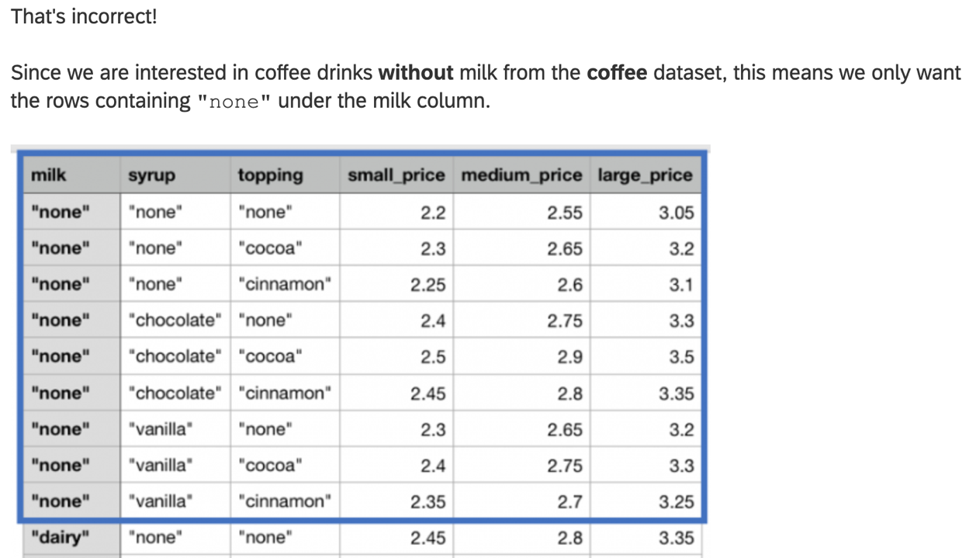

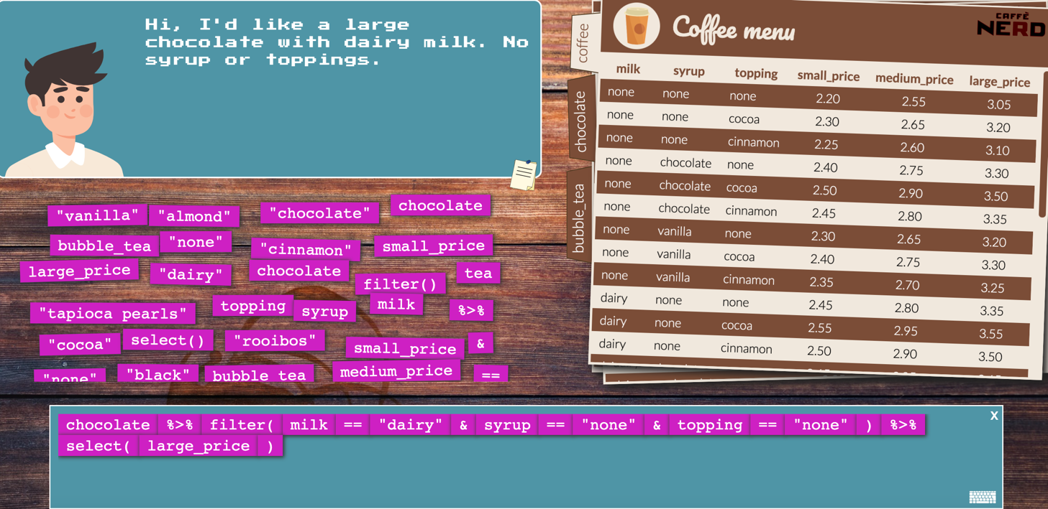C7. An example of a task in the gamified tutorial where participants must put the right codes in the correct order to determine the price value of their drink.

C8. An example of a task in the non-gamified tutorial where participants must rank the R codes according to the box they belong to.

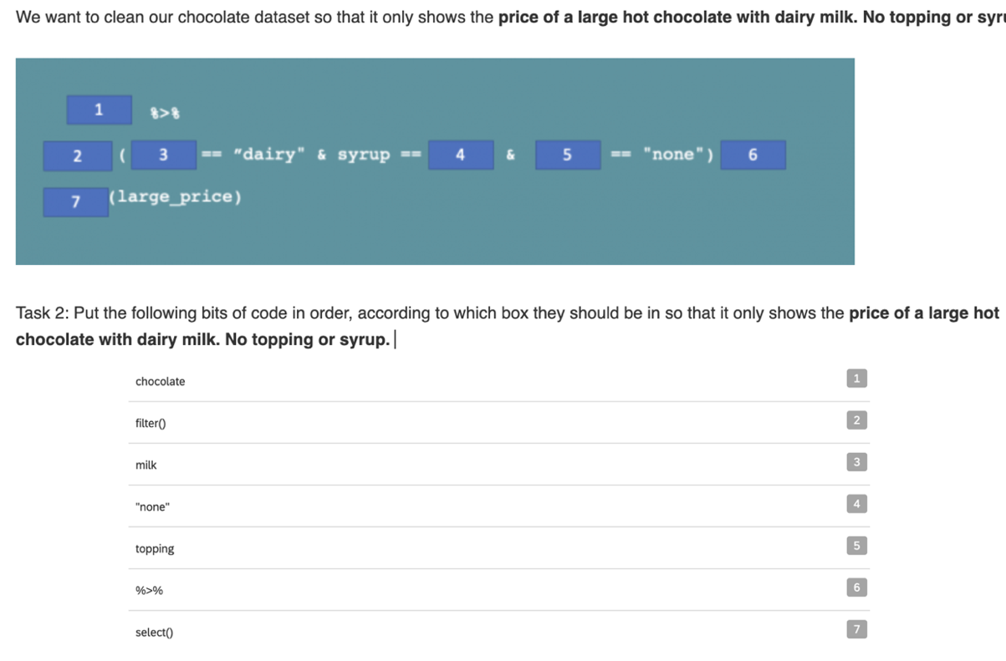

C9. An example from the gamified tutorial of a positive feedback from customers when participants enter the right code in the correct sequence.

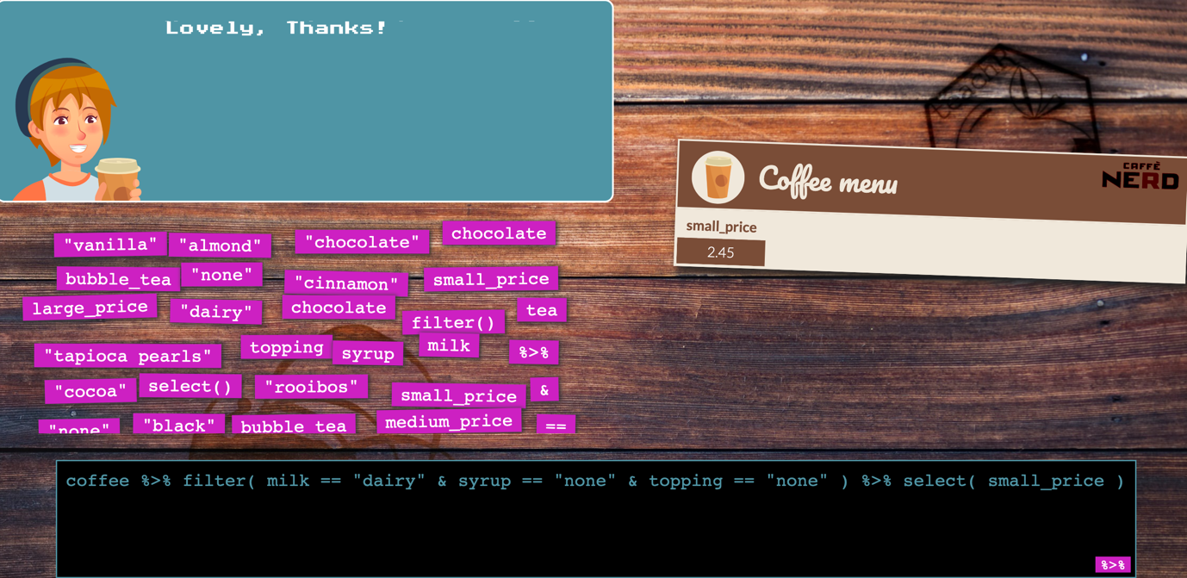

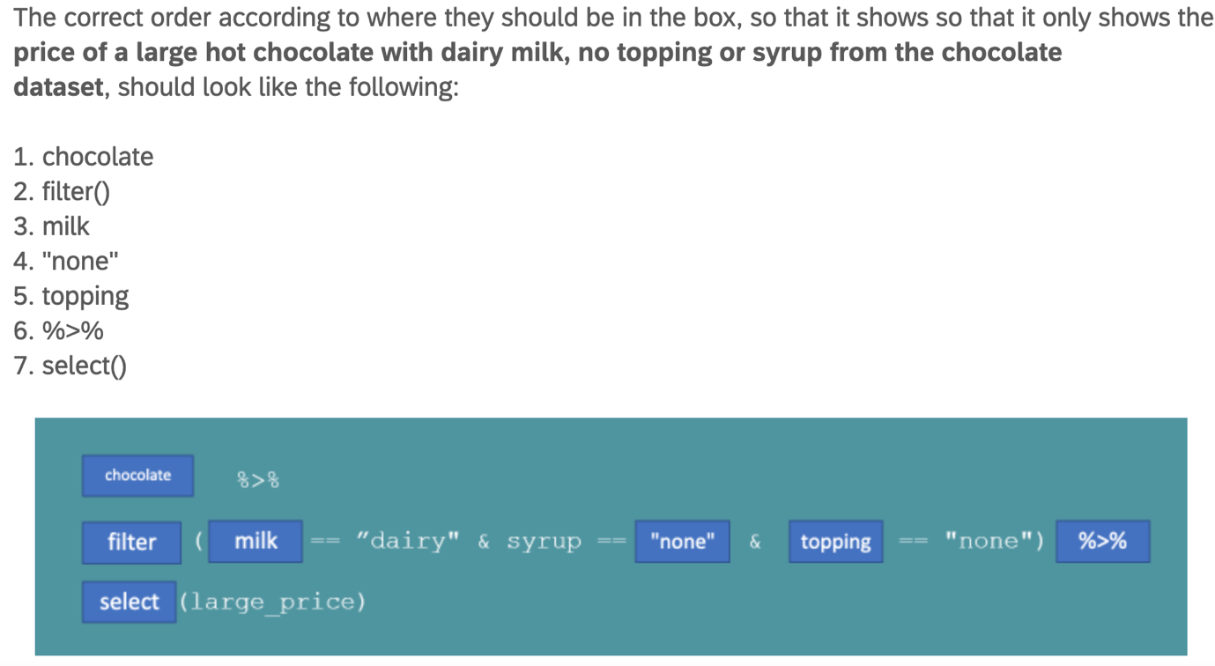C10. An example of a feedback following one of the exercises in the non-gamified tutorial.

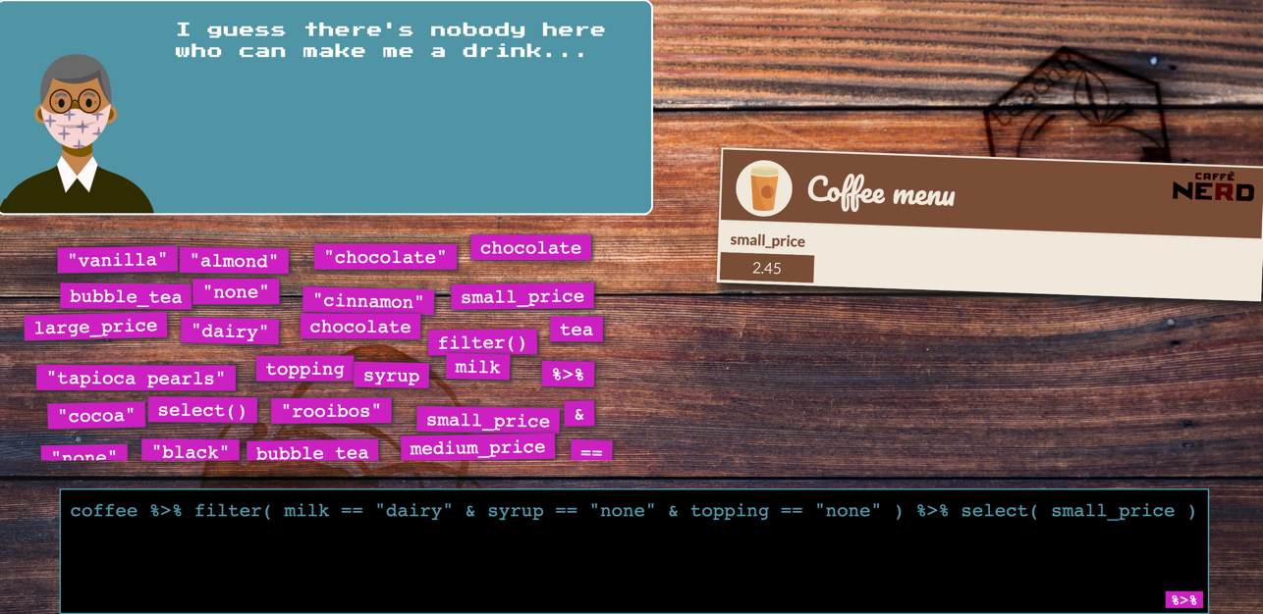C11. An example of a customer’s negative feedback displayed when participants entered the wrong code on the third attempt**.**

C12. Example of the manager’s negative facial and verbal feedback when participants serve one customer successfully out of eight.

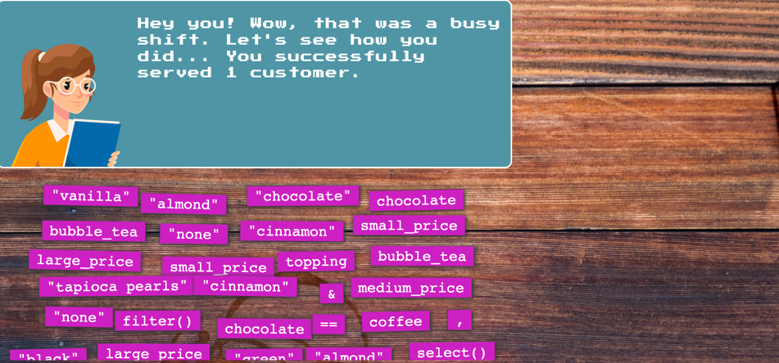

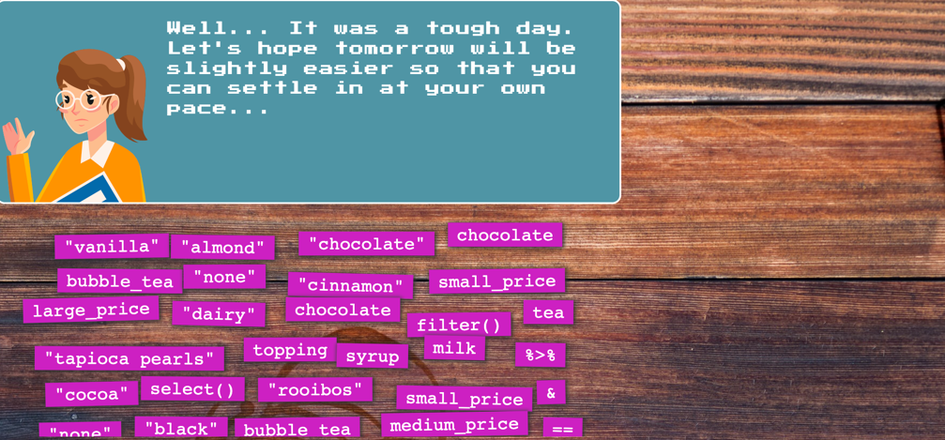

C13. Example of the manager’s positive facial and verbal feedback when participants serve all five out of eight customers successfully.

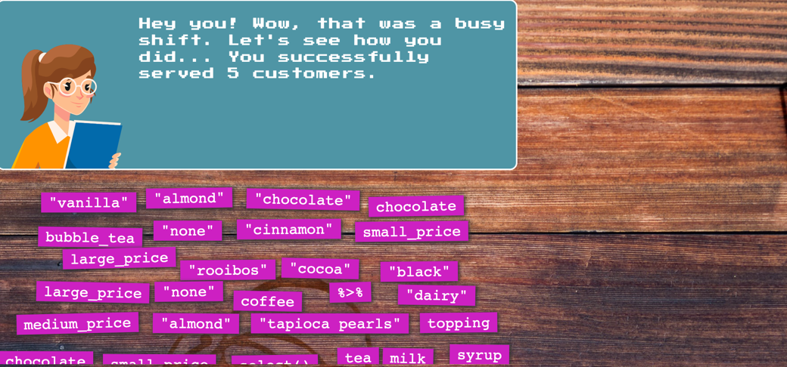

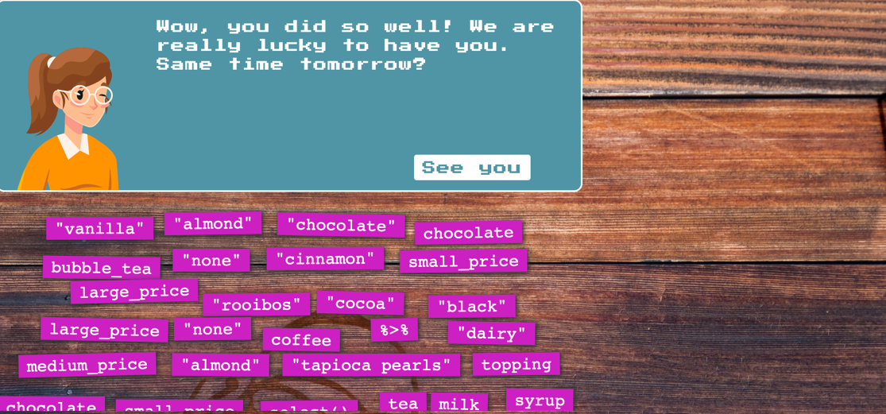

C14. An example of an easy task with the manager’s guidance.

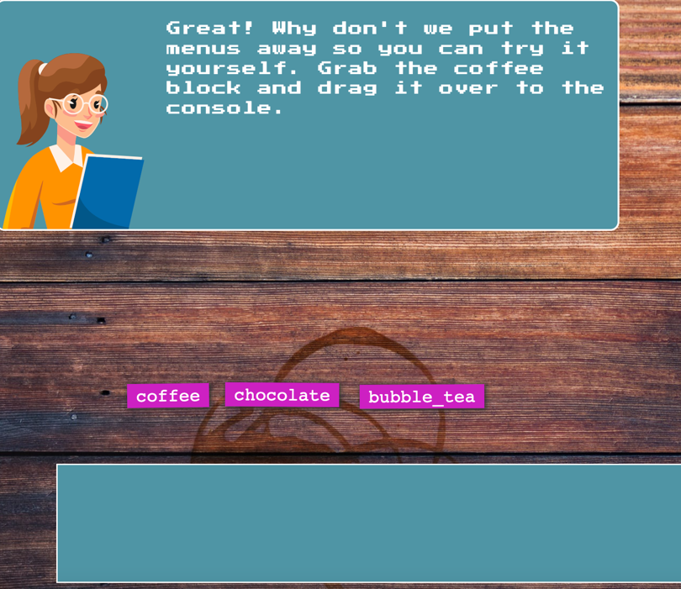

**Appendix D**

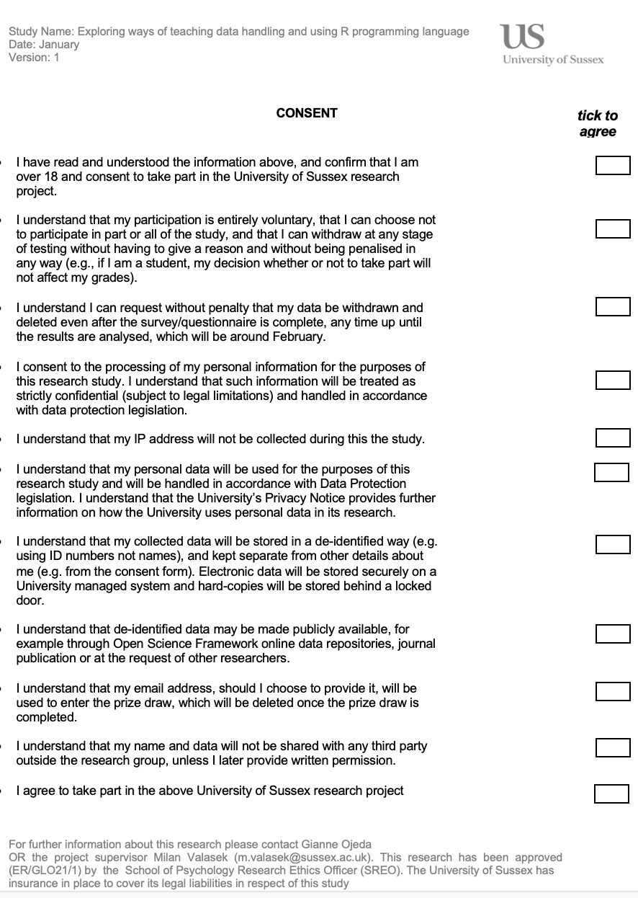Participant consent form.

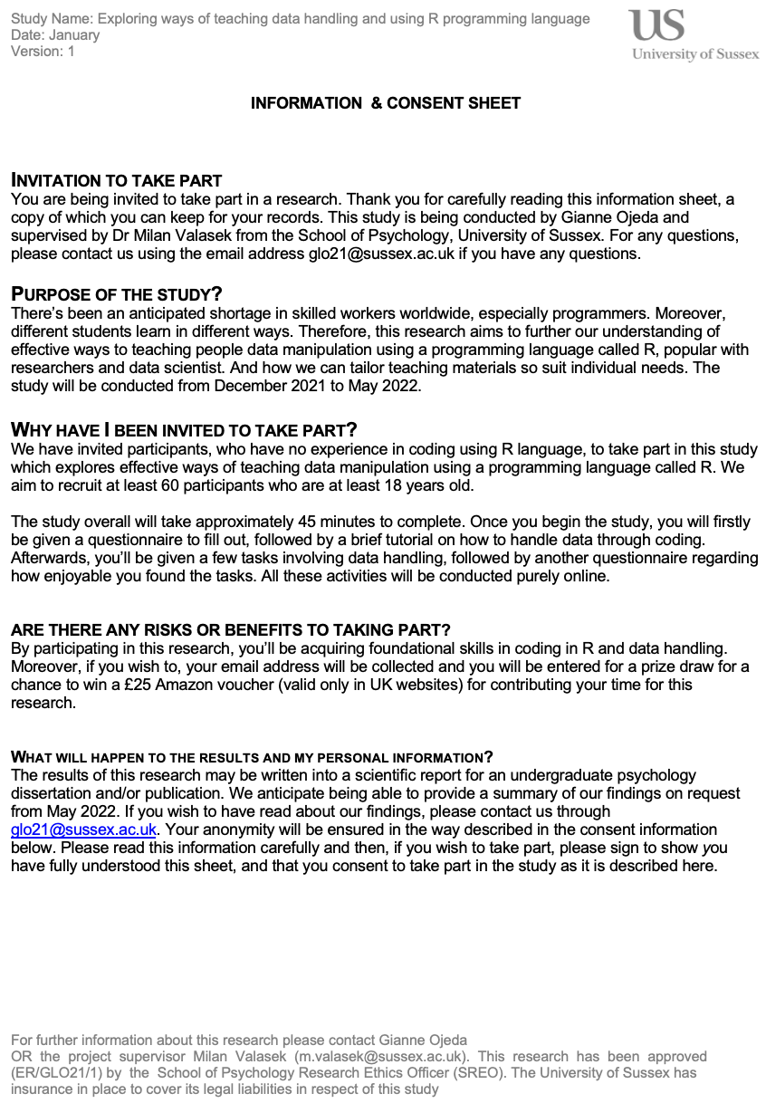

**Appendix E**

Final factor loadings and reliability of items according to our factor analysis

|  |  |  |  |  |  |
| --- | --- | --- | --- | --- | --- |
| Item | E | N | A | O | C |
| 21. I start conversations. | 0.80 |  |  |  |  |
| 31. I talk to a lot of different people at parties. | 0.78 |  |  |  |  |
| 46. I am quiet around strangers. | -0.73 |  |  |  |  |
| 1. I am the life of the party. | 0.69 |  |  |  |  |
| 6. I don't talk a lot. | -0.68 |  |  |  |  |
| 36. I don't like to draw attention to myself. | -0.63 |  |  |  |  |
| 11. I feel comfortable around people. | 0.60 |  |  |  |  |
| 16. I keep in the background. | -0.60 |  |  |  |  |

Appendix E continued…

|  |  |  |  |  |  |
| --- | --- | --- | --- | --- | --- |
| Item | E | N | A | O | C |
| 26. I have little to say. | -0.56 |  |  |  |  |
| 41. I don't mind being the centre of attention. | 0.53 |  |  |  |  |
| 12. I Insult people. | 0.39 |  |  |  |  |
| 9. I am relaxed most of the time. | 0.36 |  |  |  |  |
| 39. I have frequent mood swings. |  | 0.85 |  |  |  |
| 34. I change my mood a lot. |  | 0.83 |  |  |  |
| 44. I get irritated easily. |  | 0.77 |  |  |  |
| 4. I get stressed out easily. |  | 0.71 |  |  |  |
| 29. I get upset easily. |  | 0.68 |  |  |  |
| 49. I often feel blue. |  | 0.60 |  |  |  |
| 14. I worry about things. |  | 0.49 |  |  |  |

Appendix E continued…

|  |  |  |  |  |  |
| --- | --- | --- | --- | --- | --- |
| Item | E | N | A | O | C |
| 28. I often forget to put things back in their proper place. |  | 0.47 |  |  |  |
| 38. I shirk my duties. |  | 0.39 |  |  |  |
| 18. I make a mess of things. |  | 0.39 |  |  |  |
| 24. I am easily disturbed. |  | 0.37 |  |  |  |
| 17. I sympathize with others' feelings. |  |  | 0.87 |  |  |
| 42. I feel others' emotions. |  |  | 0.78 |  |  |
| 47. I make people feel at ease. |  |  | 0.59 |  |  |
| 27. I have a soft heart. |  |  | 0.51 |  |  |
| 7. I am interested in people. |  |  | 0.49 |  |  |

Appendix E continued…

|  |  |  |  |  |  |
| --- | --- | --- | --- | --- | --- |
| Item | E | N | A | O | C |
| 37. I take time out for others. |  |  | 0.49 |  |  |
| 32. I am not really interested in others. |  |  | 0.41 |  |  |
| 2. I feel little concern for others. |  |  | -0.34 |  |  |
| 50. I am full of ideas. |  |  |  | 0.74 |  |
| 25. I have excellent ideas. |  |  |  | 0.71 |  |
| 15. I have a vivid imagination. |  |  |  | 0.58 |  |
| 30. I do not have a good imagination. |  |  |  | -0.57 |  |
| 10. I have difficulty understanding abstract ideas. |  |  |  | -0.53 |  |
| 20. I am not interested in abstract ideas. |  |  |  | -0.51 |  |

Appendix E continued…

|  |  |  |  |  |  |
| --- | --- | --- | --- | --- | --- |
| Item | E | N | A | O | C |
| 5. I have a rich vocabulary. |  |  |  | 0.47 |  |
| 13. I pay attention to details. |  |  |  | 0.45 |  |
| 40. I use difficult words. |  |  |  | 0.42 |  |
| 45. I spend time reflecting on things. |  |  |  | 0.36 |  |
| 48. I am exacting in my work. |  |  |  | 0.33 |  |
| 23. I get chores done right away. |  |  |  |  | 0.63 |
| 3. I am always prepared. |  |  |  |  | 0.58 |
| 22. I am not interested in other people's problems. |  |  | -0.43 |  |  |
| 8. I leave my belongings around. |  |  |  |  | -0.50 |

Appendix E continued…

|  |  |  |  |  |  |
| --- | --- | --- | --- | --- | --- |
| Item | E | N | A | O | C |
| 33. I like order. |  |  |  |  | 0.46 |
| 43. I follow a schedule. |  |  |  |  | 0.32 |
| Reliability | α = 0.88 | α = 0.87 | α = 0.81 | α = 0.81 | α = 0.69 |

*Note.* E (Extroversion), N (Neuroticism), A (Agreeableness), O (Openness), C (Conscientiousness)